

**MATHEMATICS: SPECIALIST 3 & 4**

**EXTENDED PIECE OF WORK 4**

**PART B**

# HYPERBOLIC FUNCTIONS

Time Allowed: 55 minutes Total Marks: 40

No calculators allowed. Part A may be used for this Part.

**1.** [6 marks]

Sketch the following graphs. Show any important points on the axes.

(a) $f\left(x\right)=e^{x}-e^{-x}$

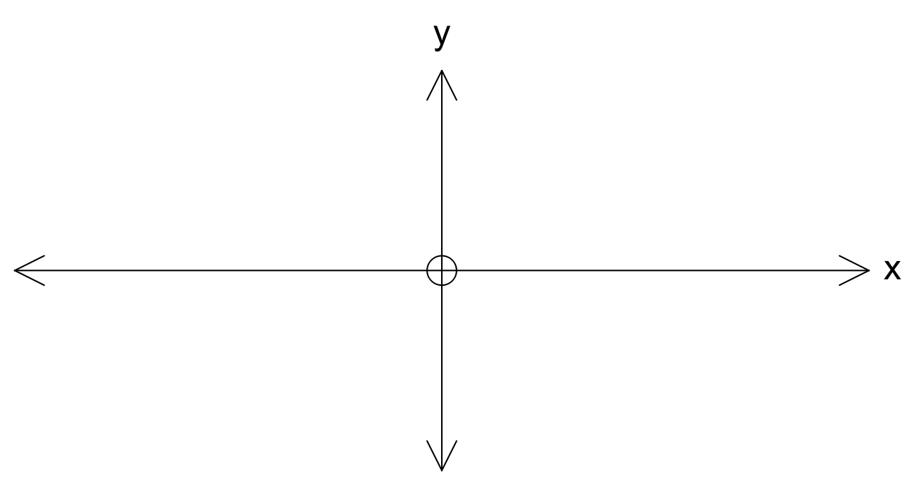

(b) $y=\operatorname{sech}{x}$, where $\operatorname{sech}{x}=\frac{1}{\cosh{x}}$



(c) $h\left(x\right)=\cosh{x}+\sinh{x}$



**2.** [4 marks]

State whether each of the following are true or false.

(a) For $x$ large and positive, $\cosh{x}$ and $\sinh{x}$ have approximately the same value.

$$\lim_{x→∞}{\tanh{x}}=1$$

(b)

(c) $\cosh{(-x)}=\cosh{x}$

(d) For $x<0$ and $|x|$ large, the graph of $y=\cosh{x}$ approximates the curve $y=\frac{1}{2}e^{-x}$.

**3.** [7 marks]

Use the transformation suggested in Question 4 of your assignment to transform the following identities into identities involving hyperbolic functions.

(a) $\cos{(A+B)}=\cos{A}\cos{B}-\sin{A}\sin{B}$

(b) $\cos{4A}=8 \sin^{4} A-8 \sin^{2} A+1$

(c) $\cos^{6} A+ \sin^{6} A=1- \frac{3}{4} \sin^{2} 2A$

(d) $\sec^{2} A- \tan^{2} A=1$

**4.** [4 marks]

Given $\sinh{x}= -\frac{3}{4}$, show that $\cosh{x}= \frac{5}{4}$.

[Hint: use Question 2 (a) from Part A]

**5.** [6 marks]

Use the results from Question 2 (c) in Part A to prove

${(\cosh{x}+\sinh{x})}^{n}=\cosh{nx}+\sinh{nx}$

**6.** [7, 6 marks]

(a) Find

(i) $\int{\cosh{x} dx}$

(ii) $\frac{d}{dx}\left(\cosh^{2} x\right)$

(iii) $\frac{d}{dx}(\sinh{5x)}$

(iv) $\frac{d}{dx}{(\cosh{x}+\sinh{x})}^{n}$

(b) Show that $\frac{d}{dx}\left(\tanh{x}\right)= {sech}^{2} x$

[Hint: Use Question 1 (b) from Part A and the quotient rule]